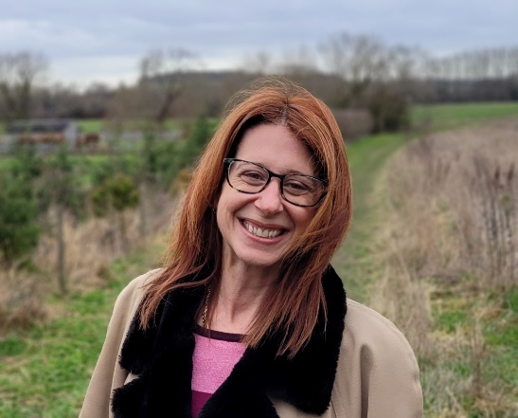
District Councillor Report
Haseley Brook ward

June 2023

Cllr Georgina Heritage

Foreword

On a personal level, I’m still undertaking a thorough training programme with SODC, however I’m already enjoying engaging with residents and parish councils in Haseley Brook, and I’m looking forward to offering parish specific updates as I become more involved with each village in the ward.

2023/24 Administration

Shortly after the local elections which saw the Lib Dems take control of SODC, an agreement was reached that we would continue our successful partnership with the Green party - a progressive approach that we believe residents voted for.

Leader, Cabinet and Chair of SODC

At the Annual meeting of South Oxfordshire District Council on 18th May Cllr David Rouane was re-elected as leader. He confirmed his cabinet as follows:

- Cllr Maggie Filipova-Rivers – Cabinet Member for Community Wellbeing, and statutory Deputy Leader
- Cllr Robin Bennett – Cabinet Member for Economic Development and Regeneration, and Deputy Leader
- Cllr Pieter-Paul Barker – Cabinet Member for Finance and Property Assets
- Cllr Sue Cooper – Cabinet Member for Environment
- Cllr Andrea Powell – Cabinet Member for Corporate Services, Policy and Programmes
- Cllr Anne-Marie Simpson – Cabinet Member for Planning
- Cllr Freddie van Mierlo – Cabinet Member for Climate Change and Nature Recovery
- Cllr David Turner will remain as Chair of the Council with Cllr Kellie Hinton as Vice-Chair.

Great Big Green Week 10-18 June

This is a national celebration of community action to tackle climate change and protect nature. The idea is that we should all try to do something to make everyone’s world a little greener.
From 12th June residents will be invited to take part in a waste satisfaction questionnaire. Questions will cover waste collections, street cleansing as well as contact made with the council waste team and Biffa. Please do provide your feedback on the current waste service. This will help when we come to designing what will follow when the Biffa contract ends.
Also from 12th June there will be a consultation on a recently produced Air Quality Action Plan. These plans have to be reviewed and updated every 5 years or so.
The air quality in our AQMAs (Air Quality Management Areas) has improved greatly, probably because vehicles are less polluting, such that Wallingford and Watlington no longer have to be declared as AQMAs. However, Henley is still so defined, mainly because of high levels of nitrogen oxides recorded in Duke Street.

Help develop our local food action plans

We’re calling for all local businesses, community growers, voluntary and community groups, food businesses and producers, and more to help us provide fairer, healthier and more sustainable local food systems for our districts.
On Friday 9th June where we’ll be raising awareness of the Oxfordshire Food Strategy at the District Community Centre in Didcot, which the councils adopted along with the other Oxfordshire councils and partners in December 2022. We’ll also be discussing the development of the South and Vale Food Action Working Group, which will work with stakeholders and partners to shape new action plans.

Council grants now available for food banks and community larders

The voluntary food network – voluntary and community organisations such as food banks, food larders and community fridges for residents – plays a vital role supporting people, but demand for their help has surged as fuel and food costs escalate, particularly for everyday staples.* While demand continues to rise, voluntary food networks are seeing their supplies reduce due to a drop in donations from individuals and companies while also facing rising fuel and food costs themselves.
To help support the voluntary food network SODC is inviting community food groups to apply for a grant of £2,500 for essential supplies. The grants can be used to help pay for a variety of expenses including food, additional storage and energy bills.
The closing date for applications is midday Wednesday 28 June 2023.
For more information on the grant and details on how to apply go to our South Oxfordshire Food Network Grant Scheme page http://www.southoxon.gov.uk/food-network-grant-scheme/
*Source: ONS Census data December 2022 and Oxfordshire County Council food cost of living data

