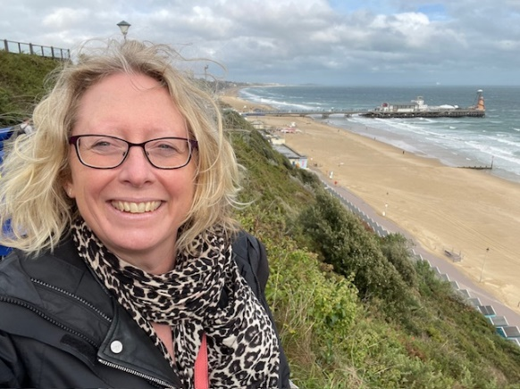
County Councillor Report
Chalgrove & Thame West Division
September 2025

Cllr Judith Edwards

My Meetings and Council Activity

After a break in August, September has been a very busy month, but I do feel that I’m starting to learn how the county council operates and make more progress. I made my maiden speech to Full Council, choosing to support a motion about the importance of Family Centres, highlighting the valuable work done by the Chalgrove & Watlington First Steps Family Hub.

I attended the Health Overview & Scrutiny meeting this month, where there was a strong focus on the state of ophthalmic services in Oxfordshire and the future of the eye hospital in Oxford. The major concern is that as large numbers of the basic eye interventions, such as cateract operations, are contracted out to private sector providers, this reduces both funding and training opportunities for the specialist NHS provision. The committee pushed hard on this issue and will keep the situation under review. I’d be interested to hear from anyone affected in this division positively or negatively and your thoughts about how we should see health develop.

I also attended the People Overview & Scrutiny meeting, where the focus was on adult social care. We considered the safeguarding function and the work that the county has done recently to support their “Age Well” policy which has seen a developing focus on early interventions and working in communities to ensure that older people are aware of local organisations that can help, tackling loneliness and isolation.

Communities have been quite a theme this month, as I’ve also attended two sessions on Neighbourhood Governance. As part of planning for local government reorganisation, the county is considering the best methods for working alongside parishes and town councils to be as inclusive as possible and give communities a real say in the decisions affecting them. This is an area really close to my heart which is why I volunteered to act as Chair for the Henley & Thame Locality Committee, which gives councillors in an area an opportunity to really delve into the issues affecting an area.

This month I also attended parish council meetings in Little Milton, Stadhampton and Newington. Unfortunately, I unavoidably missed a few this month owing to being unwell in the first week or so of September and having several meeting clashes. I’m sorry if this was your parish and you were hoping to see me there. Please get in touch on judith.edwards@oxfordshire.gov.uk if there’s a matter that you’d like to raise with me.

In respect of issues in the division, I’ve also had meetings with officers about Chalgrove Airfield, Great Haseley Industrial Estate and have been on a visit to Martin-Baker Ltd., to understand more about how the Chalgrove development would affect their business.


Lastly, it was a huge honour and pleasure to be asked to hand out the prizes at the Chalgrove Horticultural Show earlier this month which was celebrating its 60th anniversary. It was a real festival of produce, home cooking, flower arranging and photography. My absolute favourites were the contributions from local children, in a very popular category that’s due to expand next year.

Chalgrove & Thame West news

Great Haseley Industrial Estate
I have been working hard with officers at the county council and my colleague Cllr Georgina Heritage (District Councillor for Haseley Grove) to reduce the impact of the proposed base for refuse collection vehicles at Great Haseley Industrial estate. I have also been working alongside Freddie van Mierlo MP to raise residents’ concerns. The most significant issue is that of the large number of HGV movements that the site will generate, through the villages of Little Milton and Stadhampton in particular. The County Council Highways team has raised concerns about the volume of this traffic (the relevant section of the A329 is categorised as “Local Access”) in the county’s Freight Plan but frustratingly they have felt unable to go as far as to raise a formal objection. The planning application is expected to go to SODC’s Planning Committee on 8 October. When available, the agenda will be published here, and it’s possible to watch the meeting live online.

Chalgrove Airfield Proposed Development
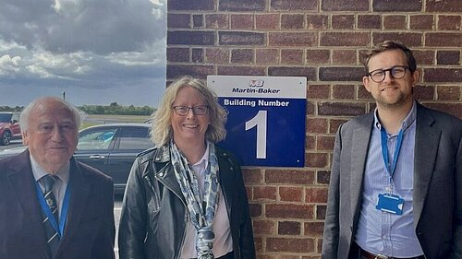
There’s been a lot of discussion about the proposed housing development at Chalgrove airfield recently, so it felt useful to find out more about the current state of play. I asked for a briefing with OCC’s planning team and also went with Freddie van Mierlo MP and Cllr David Turner (SODC, Chalgrove ward) to meet the leadership team at Martin-Baker to understand their perspective. My key takeaways from this learning are:
- The new SODC joint local plan should protect Chalgrove from a development of this size as Chalgrove is no longer in the plan, but unfortunately it is not yet in force. It is currently being examined by the Planning Inspector and confirmation of the plan is expected around December this year. Until the new plan is formally in place, the previous plan which did include Chalgrove is the most important policy which means that the site is vulnerable until that point.
- Martin-Baker Ltd. are clear that there is no viable alternative site for their operations, and they could not easily transfer the tests that they do elsewhere. The firm is crucial to the safety of air force jets around the world, and their systems have saved hundreds of lives over the years. They genuinely do not have a “Plan B” and are planning to fight not only the planning application but also any compulsory purchase order. Freddie van Mierlo MP has secured the promise of a meeting with the Secretary of State for Defence to discuss the security implications of putting this important British company at risk.
STOP PRESS! Homes England is now clearly preparing to submit a planning application to SODC in the next few weeks. Homes England are inviting residents to a public consultation event in Chalgrove at the John Hampden Hall between 2:30 and 7pm on 22nd October.

Flooding issues
The long summer drought ended abruptly over the bank holiday weekend with a significant downpour, which was followed by several more days of rain in the first week of September. Several areas in the division suffered floods and areas which have been flooded previously were watching water levels closely. I’ve been in discussions with 4 parishes about these issues and I’m doing my best to get these raised with the county’s highways team in a timely manner so that they can be addressed ahead of further heavy rainfall later in the winter.
- Tiddington had a major flood last year which was serious enough to spark a S.19 flood investigation. Teams from both county and district have spent time to understand the causes and I am hoping that we’ll see prevention action soon.
- Little Milton’s Haseley Road has been a regular problem spot for flooding, a situation compounded by the overload to the neighbouring sewage treatment works. However, I was able to get the Highways team to come and do some clearing of the road gulleys although I suspect that more work is needed.
- Great Haseley has suffered flooding around junction with Rectory Road, partly caused by a blocked drain, which had become so badly blocked that a tree was growing out of it. I’ve pushed hard on this, and the drain has now been partly cleared although the village is still waiting full resolution.
- Newington village has also suffered serious floods on the A329 in recent years, causing harm to two houses where the front doors are below the level of the road. Following an intervention from the parish council, I’ve been in touch with the highways team and will continue to push for action.
Recent gully clearance operations have made a big difference to the ability of local roads to cope with significant rainfall events but it does seem that previous cuts to this essential service have had their consequences. Some drains as in Great Haseley have been more difficult and costly to clear, and some drains may well be blocked at greater depth beneath the road. Please flag any issues in your area on Fix my street but do get in touch with me if there’s a persistent problem near you.

County news

Oxford Temporary Congestion Charge
The county council’s scheme to tackle traffic problems in Oxford in the short-term is planned to start on Wednesday 29 October.
The temporary congestion charge will reduce traffic in the city during Network Rail’s extended closure of Botley Road, making journeys quicker, more connected, more flexible and more reliable. When Botley Road reopens, the council will be able to introduce its traffic filter trial as planned.
Cars with a valid permit will be able to drive free of charge through all six congestion charge locations in Oxford. Residents are now able to apply for permits ahead of the launch of Oxfordshire County Council’s temporary congestion charge in Oxford, using an online permit registration system.

Grants available

Hardship fund: OCC’s hardship fund (Resident Support Scheme) is launched in June. Phone: 01865 804171
Home Upgrade Grants: OCC & its partner AgilityEco is reaching out directly to households who will qualify to benefit from Home Upgrade Grants (to improve energy efficiency for ‘off-grid’ homes)
Councillors’ priority grant is now available: OCC allocates a small pot of funding to each county councillor to spend on important projects in their division. This is now live for applications! All applications need to be made online – further information and a link to the application form can be found here. The decision on how to spend the funding is down to each councillor. My priorities are families, community cohesion and the environment but I’m interested in hearing about your project, whatever the theme. Please note that the SODC councillors have a similar fund so please also consider them too.

