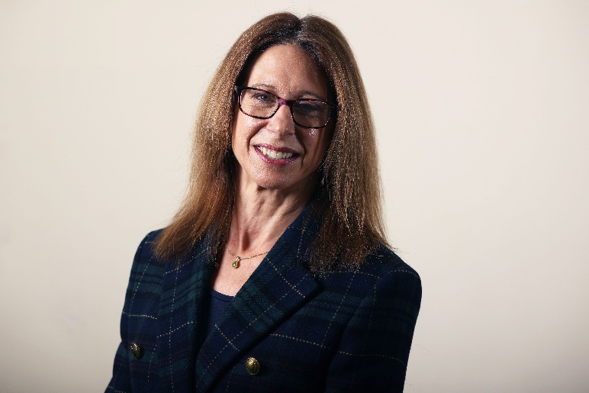
District Councillor Report
Haseley Brook ward
6th March 2026

Cllr Georgina Heritage

What I’ve been doing and local matters…
Planning application P25/S1430/O - land at Watlington Road Lewknor - for up to 25 homes was refused in February. This has been a contentious site for some time, with several applications and appeals in recent years. Amongst other considerations, several policies in Lewknor’s Neighbourhood Plan were cited as reasons for refusal. I strongly encourage villages without Neighbourhood Plans to consider developing one at the earliest opportunity, as the policies really do carry weight. I know what a lengthy and involved process this is for the volunteers who create Neighbourhood Plans but it really is a worthwhile investment of time. Although the government no longer provides national grant funding or technical packages for neighbourhood planning groups, it has reaffirmed that such plans are an important part of the planning system. SODC is committed to supporting communities with guidance and templates, and more information on this can be found here: Support We Offer - South Oxfordshire District Council
In Stadhampton, I was very pleased to meet the new owner of The Crown public house at February’s parish council meeting, Sanjay Dhrona. He and I have exchanged a few emails since, and I’m hugely encouraged that he plans to bring The Crown back as a traditional pub and friendly village hub. Sanjay wrote:
“My work with The White Hart Hotel in Dorchester-on-Thames has centred on investment, local employment, and preserving the heritage and character of our area. As employers, investors, and active community partners, we are committed to contributing positively to the local economy and ensuring that villages like ours thrive”.

Sanjay is very community-focused and the pub will be family friendly and dog friendly. Extensive works need to be carried out internally but he expects to reopen after the summer. He confirmed “We won’t be building more housing, adding bits etc. We are going to keep it as it is, but just make it perfect” which I believe will be excellent news for the village.

The White Hart Hotel sometimes hosts sell-out Indian Thali food nights, and I have to admit I’m hoping we might see the same offer in Stadhampton!

I have also been looking into a couple of areas which are not District responsibilities, but which parishes are still looking for answers on, including the number 46 bus which serves Great Milton and is largely funded by Le Manoir which is now closed for 18 months. I appreciate residents of Great Milton are concerned that the reduced service later in the day. Discussions are ongoing I believe, but the current advice from OCC is as follows:
“The County Council is providing a limited amount of funding to maintain a higher level of service in the evenings than would otherwise be the case but is unfortunately unable to provide anything further. The majority of service 46 is funded by Le Manoir; I understand that they have agreed to maintain this level of funding during the closure but this sum buys less because revenue from passengers has declined, hence the reduced level of service”.

I have continued to explore the lack of high speed broadband in certain areas of Little Milton and Great Milton, and am really pleased that our MP Freddie van Mierlo is working on this at parliamentary level, since this is something that councils sadly cannot oblige broadband providers to fulfil.

On 5th March I attended and spoke at the Connecting Local Action event at Thame Barns. It was a truly positive and inspiring event which introduced me to several community and environmental organisations that I very much look forward to staying in touch with. We heard presentations from Grow More Growers and Phoenix Energy Community. Members of the Grants team were also present to answer questions and offer advice on our grant schemes.

Over the past month I also chaired the Health Improvement Board in Oxford and the Community Safety Partnership in Abingdon. We were pleased to welcome TVP’s Community & Diversity officer Dave Hession at the CSP meeting, who is a very helpful point of contact in light of heightened community tensions in the county and the UK.

Council Matters…
February was Budget month for councils, and at SODC full council on 12th February we approved a £19.4 million budget for 2026/27, setting out plans to protect local services, invest in community facilities, provide affordable homes and manage public money carefully.
Our budget focuses on practical improvements, from leisure centres and public toilets to flood protection, support for communities and help for local businesses, while keeping the council on a secure financial footing. Our cabinet member for Finance and Property Assets, Cllr Pieter-Paul Barker, called this a “people-first budget that backs our communities, protects the services residents rely on every day and sets out a capital programme of over £100 million, including investment in community infrastructure that South Oxfordshire so badly needs.”
- The approved 2026/27 budget includes funding for numerous projects at leisure centres, including for decarbonisation projects to reduce emissions and save energy.
- There is a significant commitment to investment in housing, which now totals £25 million, both for homelessness emergency accommodation and for those most in need on the housing register, in addition to financial support for community-led housing projects.
- New ongoing funding has been agreed to support community cohesion, backing local projects that bring people together, reduce isolation and help strengthen community ties, particularly for vulnerable and marginalised residents. This is in addition to the council’s Community Hub, which will continue to help residents with housing issues, cost-of-living pressures and access to advice and support when they need it most.
- There is a record amount of grant funding at over £2 million, including £590,000 for community grants and £750,000 for infrastructure grants. This funding will help to deliver community-led projects such as village hall upgrades, improved facilities, energy efficiency projects and improvements to public spaces.
- The district council continues to invest in climate action in a way that delivers real local benefits. A new £100,000 Climate Action Fund will accept bids for nature recovery and climate adaptation including flood alleviation and access to nature for local residents, while the council will continue to make its own buildings and facilities more efficient, helping to lower long-term running costs while tackling climate change at the same time.
- Funding for the Wheatley flood alleviation scheme will help to protect at-risk homes and businesses.
- Funding has been agreed to continue the council’s economic development work, helping businesses to start up, expand and adapt, supporting high streets, rural employers and the local economy more widely.
Residents will pay an average £156.24 for services provided by the district council for 2026/27 - £3 per week, with its share of the council tax increasing by £5 a year for a typical Band D household. This small increase helps to protect frontline services and fund investment in local facilities, while ensuring the district’s council tax remains one of the lowest in the country.
Cllr Barker said: “At its heart, this budget is about backing our communities – keeping leisure centres and public toilets fit for local needs, helping protect homes from flooding, supporting community projects and ensuring help is there for people who need it. These are not abstract figures, but practical investments that make a real difference to everyday life across South Oxfordshire.
“We are determined to look after every pound of taxpayers’ money, especially with local government reorganisation on the horizon. This budget has been set responsibly, based on clear priorities and realistic planning, so that whatever changes lie ahead, South Oxfordshire remains financially strong.”
To view the approved 2026-27 Vale of White Horse District Council budget, visit the 12 February 2026 Council meeting agenda page.

As cabinet member for Communities, I’m particularly pleased that we’re able to offer such a comprehensive package of grant funding, which many councils are not in a position to do. It was very important to us that as part of this year’s budget we were able to continue to support community and non-profit organisations across the district and putting people first. These groups carry out vital work to support the vulnerable and most in need in South Oxfordshire, and on projects that help our natural environment to thrive.

The schemes coming up this year and their provisional launch dates are as follows:
- Everyone Active Grant: £50,000 launches 30 March – for projects that improve the health and wellbeing of residents
- Capital Grant Scheme: £320,000 launches 1 June – for projects such as play areas, community and sports facilities, and sustainability projects
- Performing Arts Grant Scheme: £60,000 launches 20 July - designed to enhance the cultural landscape and support local performing arts groups
- Councillor Community Grant Scheme: £270,000 launches 17 August – for projects and activities that offer community benefits including sports equipment, trees for community orchards, events for the elderly
- Climate Action Fund: £100,000 launches 28 September – aimed at projects that help to tackle climate change and nature recovery.
- Community Infrastructure Levy Grant: £750,000 launches 15 February 2027 – for organisations to deliver infrastructure for their community

The current CIL grant is still open until 30th March 2026. More information about this can be found here:
Community Infrastructure Levy (CIL) Grant Fund - open - South Oxfordshire District Council

Please consider signing up to our Community Grants newsletter. You can sign up from SODC’s Grants webpage, and March’s newsletter will include information about the upcoming grants programme for 2027/28.

Finally, I would like to offer a short summary of the outcomes from the JLP Procedural Meeting which took place on Thursday 12th February (and if interested you can also watch the meeting, which was live streamed and watched live by around 120 viewers):

Agenda
The agenda covered matters of process only, with discussion between the Inspectors and Council officers/ Michael Bedford our KC, and no other participants. There was, as expected, no discussion on the soundness or content of the plan, that will be for the future hearing sessions.
Summary of events
The Inspectors ran through a summary of the events that had got to us to here. They explained that they still needed to decide on next steps, but on the positive side, they asked us about timings for additional documents to be submitted and hearings to take place.
Timeline for the next stage of hearings
The Council proposed an indicative timeline, with short term dates for submission of documents and for the Inspectors to issue MIQs (matters, issues and questions) for participants to prepare statements on prior to the hearings. We suggested there might be 4 weeks of hearings and expressed a preference for gaps between weeks (this takes into consideration other workload like next local plan commencement notice required by 30 June 2026).
They will consider a simple timeline that we submit on 13 February. This will show our preference to complete hearings in June and July 2026. The Inspectors indicated that they want to re-open some of the topics that they heard last June.

Engagement
The Inspectors noted there are currently no specific requirements on how engagement should be treated as a soundness consideration (post-legal duty to cooperate). Michael Bedford our KC suggested examining the Plan in accordance with National Planning Policy Framework (2023) paragraph 26, treating any cooperation-related issues as matters of policy effectiveness and soundness.

NPPF
The Inspectors confirmed that under the government's transitional arrangements, the JLP will be examined against the 2023 version of the National Planning Policy Framework, not the NPPF 2024 version, and not the draft NPPF 2025 that the government is currently consulting on.

Next steps
- The Councils will provide the Programme Officer with a summary of programme preferences and a timeline on 13 February. We will set out that we are happy to work with the Inspectors and will offer as much flex as possible.
- The Councils will submit a Note by 27 Feb answering questions already set out in the Inspectors' letter (ID13 para 4).
- The Inspectors will publish a letter setting out the next steps, on the Examination webpage.

