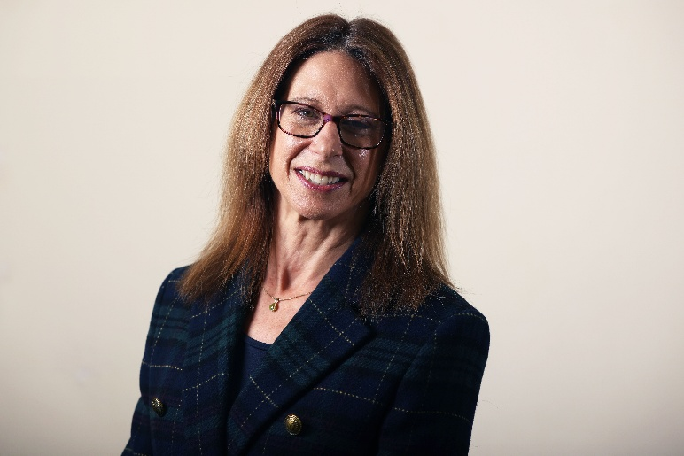
District Councillor Report
Haseley Brook ward
1st October 2026

Cllr Georgina Heritage
georgina.heritage@southoxon.gov.uk

Local Matters and what I’ve been doing

Most of my resident and parish council casework over the past month has been planning-related and I’m still working hard to assist with those. There hasn’t been a particular theme to these cases, they have tended to have complications in their own right, but the past few weeks have certainly heightened my frustration and disappointment about the government’s reforms to planning committees, meaning that neither I nor parish councils can no longer call applications in to planning committee hearings.

At a Special Council meeting called on 24th September, we were required to make changes to SODC’s constitution to allow for this reform. The irony was that we were obliged to vote for the constitutional changes even though we had no say in the new national system and feel very strongly against it.

After a very lengthy and complex debate, the necessary changes were approved, however SODC councillors and officers have worked hard to ensure the agreed changes seek to make the minimum amendments necessary, while retaining the maximum level of member involvement permitted under the new legislation.
Councillors voted reluctantly. I elected to abstain in protest, but I fully recognise that abstaining was effectively performative. Not making the changes would have resulted in the council not following the law.

As a reminder, the new system takes effect from 31st October, and key changes include:

- A mandatory national scheme of delegation. Where previously, every local council created its own rules, the new system creates one standard rulebook for the whole country – with the aim of speeding up and streamlining the planning approval process.

- Most everyday planning applications will automatically be handed to professional planning officers to decide. Only very large, complex, or highly controversial projects are allowed to be decided by a planning committee.

- A smaller project can only be pushed up to the committee if it passes a strict “gateway test” to demonstrate that the proposal has significant impacts affecting the wider community, and that request will need to be agreed by a nominated officer.

SODC’s cabinet member for Planning Development, Cllr Ben Higgins, was quoted:
“These mandated changes take power away from locally elected representatives at both parish and district level and are the opposite of devolution. Under the existing regime, committee passed the vast majority of applications for residential dwellings when applications were referred.
“These changes will make at best a marginal difference in the number of homes built, at a significant cost to local accountability and potential faith in local democratic processes. Our hands are now tied as the government is enforcing these rules across the country. We will work with our dedicated planning officers to implement the requirements – and do everything we can to make the best of this challenging new situation.”
The reports can be viewed here: South Special Council meeting on 24 September

In September I was delighted to launch South and Vale’s Community Cohesion Strategy project with my Vale cabinet member counterpart. The aim is to build stronger communities, develop connections and foster neighbourhood togetherness, and the strategy is the first of its kind in rural districts. We want to foster integration by encouraging social participation, cultural understanding and mutual support. It also aims to build long-term independence and resilience among the communities it supports. Linked to smaller community initiatives, the Councils’ longer-term, resulting in an evidence-based Community Cohesion Strategy.

We were able to secure some funding and we are working with Belong – The Cohesion and Integration Network. An online survey has been created that I would really appreciate parish councils and residents getting involved in. As well as completing the survey yourselves, please could you think of community groups you could share it with? Especially those who might not follow council comms, are harder to reach or are less heard. The more people with different experiences who can contribute, the more meaningful the outcomes are likely to be.
Please take part in the online survey and share views and experiences within their own communities. The survey closes on Friday 13 November.
Links to the survey and further information on the project, alongside regular updates are available at www.southandvale.gov.uk/APlaceForEveryone

I’m looking forward to visiting the new Oxfordshire CCTV suite at Abingdon police station on 2nd October, and most of the committees I’ve attended this month have related to police and crime or health. I represented SODC on the Thames Valley Police & Crime panel on 11th November, and on the newly formed Thames Valley Serious Crime Board on 29th September. In health, I chaired the Health Improvement Board (HIB) at County Hall on 17th September, a sub-committee of the Health & Wellbeing Board (HWB). I then represented SODC at the Health & Wellbeing Board in which I presented a report on HIB’s work.

You can find more details of the agendas for these meetings via these links:
Agenda for Thames Valley Police and Crime Panel on Friday, 11th September, 2026, 10.30 am - Modern Council

Agenda for Health Improvement Partnership Board on Thursday, 17 September 2026, 2.00 pm | Oxfordshire County Council

Agenda for Oxfordshire Health & Wellbeing Board on Thursday, 24 September 2026, 1.00 pm | Oxfordshire County Council

Last month I included a motion in my report by Chinnor’s District Councillor Ed Sadler, which I seconded. He and I have been focusing on antisocial driving and excessive vehicle noise in our area, and councillors and are aware that residents throughout South Oxfordshire have been suffering from similar issues. While responsibility for enforcing road traffic legislation sits primarily with Thames Valley Police, residents frequently raise these issues with the district council because of the significant effect they can have on everyday life, particularly in rural communities and along popular driving and motorcycling routes.
SODC leader Cllr Maggie Filipova-Rivers has now followed up on this motion by writing to the Police & Crime Commissioner and, once a response is received, the council will share with local MPs, OCC and parish councils. The letter is as follows:

Dear Mr Barber,
Excessive Vehicle Noise and Anti-Social Vehicle Use in South Oxfordshire
I am writing on behalf of South Oxfordshire District Council regarding excessive vehicle noise pollution and anti-social vehicle use within the district. Concerns are increasingly being raised by residents across South Oxfordshire regarding the impact of excessively noisy vehicles, including motorcycles and cars fitted with modified or non-compliant exhaust systems, as well as the illegal use of off-road motorcycles.
Councillors recognise that responsibility for enforcing road traffic legislation relating to vehicle noise rests primarily with Thames Valley Police. However, residents frequently raise these concerns with the district council because of the significant effect that persistent vehicle noise and anti-social driving can have on quality of life, particularly in rural communities and along popular driving and motorcycling routes.
The Council believes that residents should be able to enjoy their homes and communities without unnecessary disruption from excessive vehicle noise and anti social vehicle use. We are therefore keen to understand how these issues are currently being addressed across South Oxfordshire and how local agencies can work together more effectively to support affected communities.
I would be grateful if you could provide information on:
• The number of reports received by Thames Valley Police relating to excessive vehicle noise and vehicle-related anti-social behaviour across South Oxfordshire;
• The enforcement activity undertaken in response to such reports;
• How Thames Valley Police is currently addressing vehicle-related anti-social behaviour within the district; and
• Any planned initiatives or operational activity aimed at tackling these concerns.
The Council would also welcome the opportunity to work collaboratively with Thames Valley Police, Oxfordshire County Council and our town and parish councils to develop an evidence-based understanding of recurring vehicle noise and anti-social driving hotspots. We are particularly interested in exploring how reporting data and hotspot mapping could be used to identify problem locations and inform targeted enforcement activity.
In addition, we recognise the importance of ensuring residents understand how and where they should report concerns. We would therefore welcome any opportunities to support efforts by Thames Valley Police to improve public awareness of reporting mechanisms and the enforcement powers available to address these issues.
I look forward to your response and any information you can provide. Once received, the Council intends to share your response with local Members of Parliament, Oxfordshire County Council and town and parish councils to help raise awareness of the issue and support wider partnership working.
Thank you for your consideration of this matter. I look forward to hearing from you and to continuing our joint efforts to address the concerns of South Oxfordshire residents.
Yours sincerely
Councillor Maggie Filipova-Rivers
Leader of the Council

Council Matters

Very little information has been offered by Government regarding the next steps for Local Government Reorganisation but I appreciate that the current pause is a welcome reprieve for the villages in Haseley Brook that would have become part of Greater Oxford. The information we have received from Minister Jim McMahon following a council webinar is as follows:
The government remains committed to LGR and devolution but wants to take time to review the decisions made to date. He stated that the review is intended to provide confidence that the process has been followed correctly, and that any future decisions align with the government's priorities, are sustainable and can be implemented successfully.
The government has not yet agreed the scope of the review but aims to complete it by mid-October, although no firm commitment was given on timing. The minister also indicated that shadow elections to the new councils are now unlikely to take place in May 2027 and that elections to existing councils will proceed as they would have done without LGR.
The timeline for Oxfordshire may therefore be moved back. This will give more time to plan and deliver the transition, which is positive given the scale of the work needed to be done. The change in timeline also means the existing councils are likely to continue for at least another year and the South Oxfordshire and Vale of White Horse district council elections will take place in May next year instead of shadow elections for a new unitary.
While the review is underway, we’ve been asked to pause work that is directly related to establishing new authorities but can continue with preparatory work where it supports future decision-making and enables us to move at pace once the review is complete.
Over the coming weeks, we will continue to work closely in partnership with the other Oxfordshire councils and West Berkshire to review what work should continue and what needs to be paused for now.

As well as the Councillor Community Grant being open for applications, a new £100,000 SODC grant scheme has also just opened to tackle climate change and support nature recovery. The Nature and Climate Action Fund is open to voluntary and community organisations, and applications can be made for £250 to £10,000.
Projects could include making a village hall more energy efficient, restoring natural habitats such as floodplain meadows, planting trees for shade and to reduce flooding, organising a community learning event on home renewable energy options or installing bike racks at a community venue to encourage cycling.
The fund will support projects that:
- Address climate change and avoid or reduce the emission of greenhouse gases (mitigation projects)
- Adjust to the current and future effects of climate change (adaptation projects)
- Support nature recovery and biodiversity

Groups do not need to be experts in climate change or nature recovery to apply. The council welcomes applications from organisations that are just getting started, as well as those with more experience.
Organisations eligible to apply include town and parish councils and local ‘not for profit’ organisations, and town/parish councils can also collaborate with local unconstituted groups and apply on their behalf.
Full details including how to apply, are available on the council's website and organisations can also contact our Climate and Biodiversity Team by emailing climateaction@southandvale.gov.uk with questions about any projects they would like support with.
More details about all our grants, eligibility and how to apply can be found on the South Oxfordshire District Council grants webpage.

Following delays in delivering South Oxfordshire and Vale of White Horse District Councils’ new Land Charges system this year, a report has been published setting out the causes of the project delays and identifying lessons learnt. The report went before the councils’ Joint Scrutiny Committee on Monday 7 September in which members of the committee reviewed the report and concluded that lessons from the Land Charges project should lead to improvements in project governance, risk management, transparency of communications, access to specialist expertise and collaborative working on future systems. The committee also formally acknowledged the considerable effort of officers, contractors and partners put in towards stabilising and operating the service.

